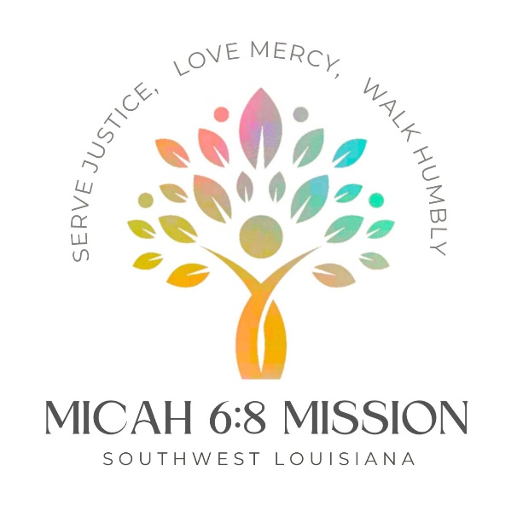

Community Compass Connections
Informing our community in Portie Town and throughout Southwest Louisiana
February 2024, Micah Six Eight Mission

Table of Contents
- Where We Are pp 2-3
- Did You Know? pp 4-5
- Meet Our Team p 6
- Save the Date p 7
- Contact Us p 8

Where We Are
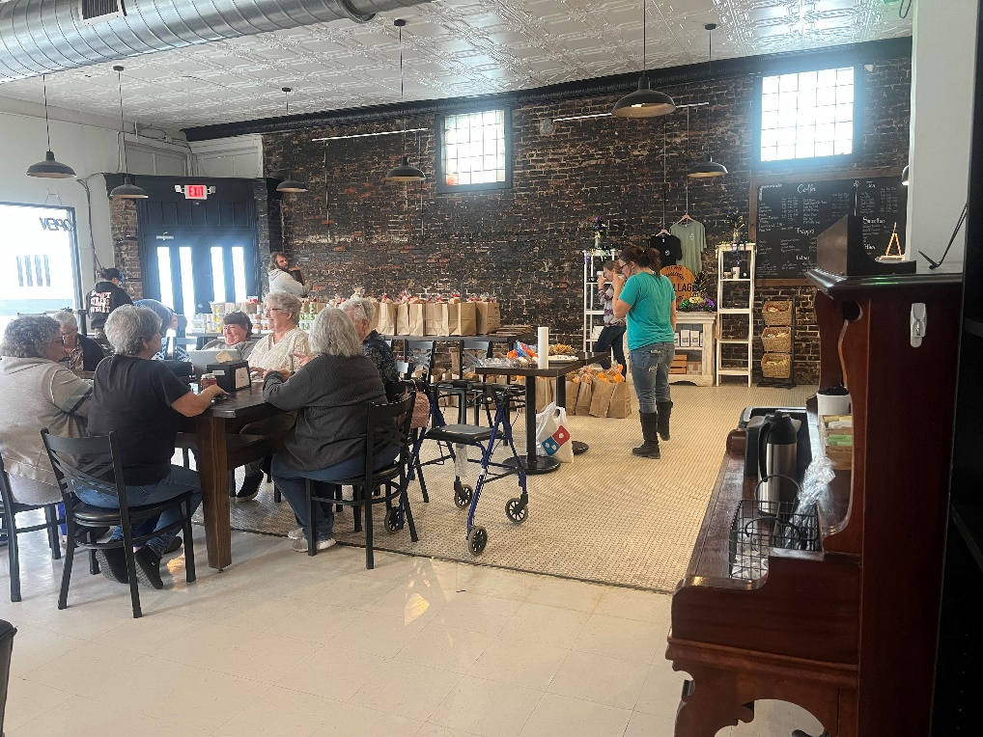

Our Community Compass Sharing Sundays are off to a good start. In December we shared Christmas dinner bags with the community. January, we shared more food, and hosted a community meal to bring folks together. Robyn cooked a wonderful beef stew, and we had close to 50 people who enjoyed the meal. These events are always held at The Village Coffeehouse in Sulphur and will continue for the foreseeable future. February’s Second Sunday Sharing will be held February 11th, from 3 – 6pm. We will have bags of toiletries and paper goods to share. Join us to pick up a bag, visit with your neighbors and find out what we are working on now!
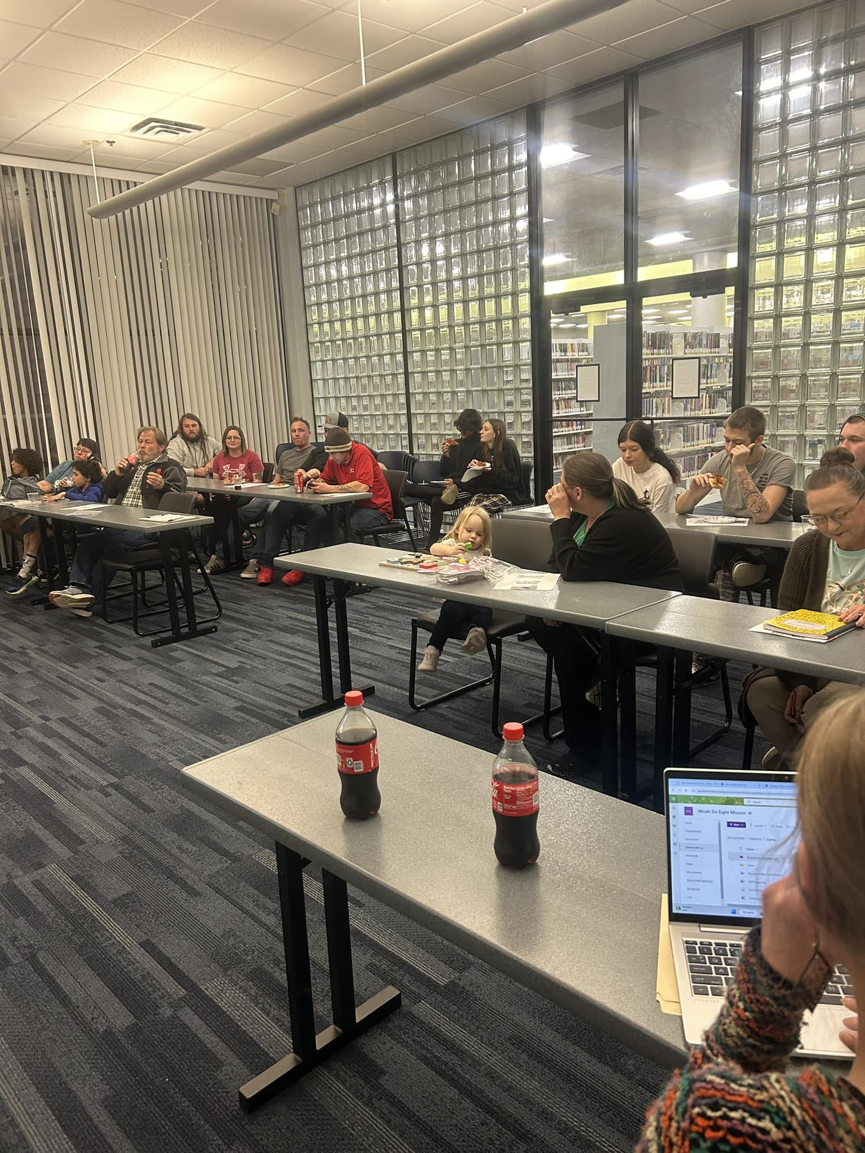

SWLA Better Together Community Meetings bring knowledge to our community. We started out asking the community what you wanted to have information about. We have covered how to write comments to state and federal agencies and understanding our air quality. The 3rd Thursday meeting in February at the Sulphur library (2/15/24, 6pm) will explain what all the fuss is about Biden pausing the LNG (Liquified Natural Gas) export approvals. Programs for March will include information on the Sulphur Salt Dome.

Did You Know??

• By replacing one disposable cup a day for one year with a reusable mug, 281 gallons of water can be saved.
• The use of efficient dishwashing equipment has the potential to reduce overall energy usage by 45% for a reusable system.
• Even when using older dishwashers, reusables use less energy than disposables.

Reusables Save Water and Energy Use
On a planet of 7 billion people and growing, products that are designed to be used for just a few minutes before they become waste is not sustainable. We are never going to be able to recycle or compost our way to a sustainable future. The throw-away economy treats both people and the planet as disposable. The throw-away economy uses 35 billion gallons of water annually. Which is enough to fill almost 53,000 Olympic size swimming pools.¹
Reusables produce a smaller water and energy consumption footprint than their disposable counterparts due to all the upstream production impacts that disposables create.
Reusables always hit a break-even point where they outperform the disposables, and the benefits to the environment accrue with each additional use past that point. The break-even points range from 2-122 times – with materials like steel, glass and ceramics being used thousands of times.
By replacing one disposable cup a day for one year with a reusable mug, 281 gallons of water can be saved!²
The use of efficient dishwashing equipment has the potential to reduce overall energy usage by 45% for a reusable system.³
Even when using older dishwashers, reusables use less energy than disposables.⁴
Endnotes 1 “Case Studies, Download Resources.” Resources | ReThink Disposable 2 id. 3 Life Cycle Environmental and Cost Analysis of Disposable and Reusable Ware in School Cafeteria. Prepared for by School Nutrition Foundation, by Franklin Associate. Published November 2009. Page 9, para. 2. Accessed March 31, 2022. 4 id. 5 “Case Studies, Download Resources.” Resources | ReThink Disposable. 6 id.
An Example
Crispian Bakery Added Dishwashing Capacity, No Labor Added
Crispian Bakery serves coffee and pastry for up to ten on-site diners. The cafe switched to using reusable service ware for their on-site customers and instituted a discount for those who brought their own mugs for takeout. They now rent a dishwasher for $75 a month, after an installation cost of $500. Their water bill only increased by an average $30 a month. By switching to reusable plates, cups, and silverware, the Crispian Bakery saves a net $1,700 annually.
THAT’S A LOT OF MONEY IN ONE YEAR!
Sourced from https://upstreamsolutions.org/climate-plastics-reuse/#resources

Meet Our Team!

Carrie Bauer recently joined us as our Program Manager, which means she oversees organization – the coordination of EVERYTHING!. Carrie does this work because she is “extremely passionate about the environment we live in and how it affects the members of our community.”

She is the voice you reach when you call: 337-888 6791.

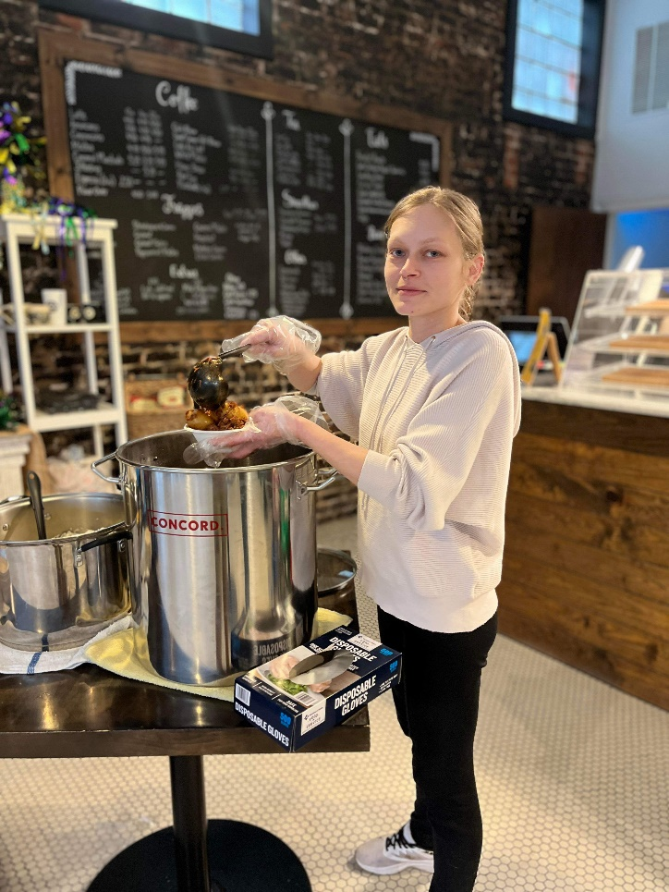
"The earth is what we all have in common." - Wendell Berry
Save the Dates for February

2/11/23, Community Compass Sharing Sunday
– dry goods & toiletries!
The Village Coffeehouse, 3-6pm

2/14/24, SWLA Better Together Meeting
- LNG: What’s All the Fuss About?
Sulphur library, 6-7p

2/21/23, Community Compass Sharing Sunday
– community meal
The Village Coffeehouse, 3-6pm

REMEMBER, YOU CAN REFILL YOUR LAUNDRY DETERGENT AND DISHWASHING LIQUID AT ANY OF OUR EVENTS!!!

WHAT DO YOU WANT TO KNOW ABOUT?
Shoot us an email if there is a topic you want us to discuss at our meetings: micah68mission@micah68mission.org
Are you experiencing higher than usual utility bills? Please contact us through the email above or come to a 1st & 3rd Thursday SWLA Better Together meeting at 6pm at the Sulphur library.
Are you concerned about the safety of our water? Please contact us through the email above or come to a 1st n& 3rd Thursday SWLA Better Together meeting at 6pm at the Sulphur library.
Anything else you want answers about? Email us!!

Contact Us!!

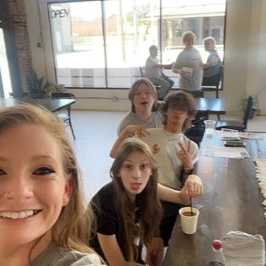
We welcome emails, which are the best way to connect with us.

Micah Six Eight Mission
624 W. Verdine
Sulphur, LA, 70663
337-888-4649
micah68mission@micah68mission.org
Visit us on the web at www.micah68mission.org
If you were forwarded this newsletter and want to connect with us directly to get the newsletter of for updates on events, etc. please fill out this form.

